

FACULTY OF ENGINEERIN AND TECHNOLOGY
ELECTRICAL AND COMPUTER ENGINEERING DEPARTMENT
ADVANCED DIGITAL DESIGN ENCS3310
COURSE PROJECT

Instructors: Abdellatif Abu-Issa & Elias Khalil

Objective:

The task is to design a fast multiplier and then to write a complete code for verification. You should search for information about the following types of adders: Ripple Adder, Look-ahead Adder, and the multiplier.

The Task:

Your task is to create a library element that has the following appearance:

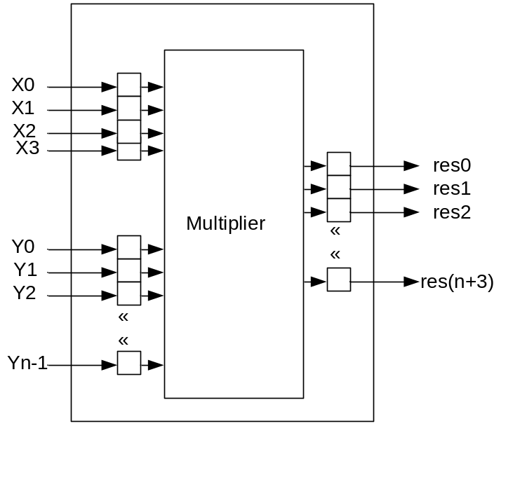

The multiplier has two inputs: the multiplier x which is 4 bits, and the multiplicand y which is generic (n bits). Also it has one output called res which is (n+4) bits. The inputs and the output are fed through flip-flops.
The multiplier is to be built structurally from a library of gates, which contains the following devices and delays in nanosecond (ns). (Your delay depends on the least significant digit of your student ID).

Gate\ID | 0 | 1 | 2 | 3 | 4 | 5 | 6 | 7 | 8 | 9
INV | 1 | 2 | 1 | 2 | 3 | 4 | 3 | 1 | 4 | 2
AND | 2 | 3 | 3 | 4 | 4 | 5 | 5 | 5 | 6 | 7
OR | 2 | 3 | 4 | 4 | 4 | 5 | 5 | 5 | 6 | 7
NAND | 3 | 4 | 4 | 5 | 6 | 7 | 8 | 6 | 9 | 8
NOR | 3 | 4 | 5 | 5 | 6 | 7 | 8 | 6 | 9 | 8
XOR | 4 | 5 | 6 | 7 | 8 | 9 | 10 | 8 | 10 | 9
XNOR | 5 | 6 | 7 | 8 | 9 | 10 | 12 | 9 | 13 | 10

Stages of the project:

The project is split into two stages of complexity, and you can choose how complex a system you wish to attempt to implement.

Stage 1
The multiplier should be implemented using adders and the required gates. The first type of the adders to be used is the ripple carry adder which should be built structurally as follows:
- Built 1-bit full adder from the basic gates given above.
- Use the full adder to build 4-bit adder.
- Use as many blocks as you need of the 4-bit adder when you build the multiplier.

You should produce complete verification (or large number of random cases) to demonstrate the multiplier working as expected. You should determine the maximum latency of the multiplier. And therefore, what is the maximum frequency of clock that can be applied to the flip-flops. Also, you should introduce an error in your design and to do a verification that will discover the error.

Stage 2
The second type of adders to be used is the carry look-ahead adder. You should implement a 4-bit adder structurally using the basic gates given above. Use as many blocks as you need of the 4-bit adder when you build the multiplier.
You should produce complete verification (or large number of random cases) to demonstrate the multiplier working as expected. You should determine the maximum latency of the multiplier. And therefore, what is the maximum frequency of clock that can be applied to the flip-flops. Also, you should introduce an error in your design and to do a verification that will discover the error.

Key Points:

- This is an individual project.

- Any type of plagiarism or cheating will be penalized by 0 mark, and the cheaters will be treated according to the university laws.

- This Project will take 15% of the final mark in the course.

- Technical achievement in design is linked to the degree of functionality that was attempted, as explained below.

- Technical achievement in implementation is based on the quality of your Verilog code. This includes issues such as legibility of code, use of meaningful variable names, good comments, clear structure, and modifiability of the design.

- Technical achievement in evaluation is based on the quality of your simulation results.

Mark scheme for technical achievement:

Design Attempted | Successful Implementation, using of comments and meaningful variable names, good simulation, good structure of the code…etc.
Stage 1 | Up to 70%
Stage 1 and 2 | Up to 100%

Deadline:

- Deadline: Sunday 26/5/2024 till midnight.
- Late submission is penalized at a rate of 2 mark per day till Sunday 02/06/2024.
- Earlier submission will give positive impact.
- In submission, we look at the date not the clock!!
- Discussion will be held for each student.

